Q1: Write a PL/SQL block to add 10% more interest on loan type = home loan

ANSWER: NORMAL PLSQL

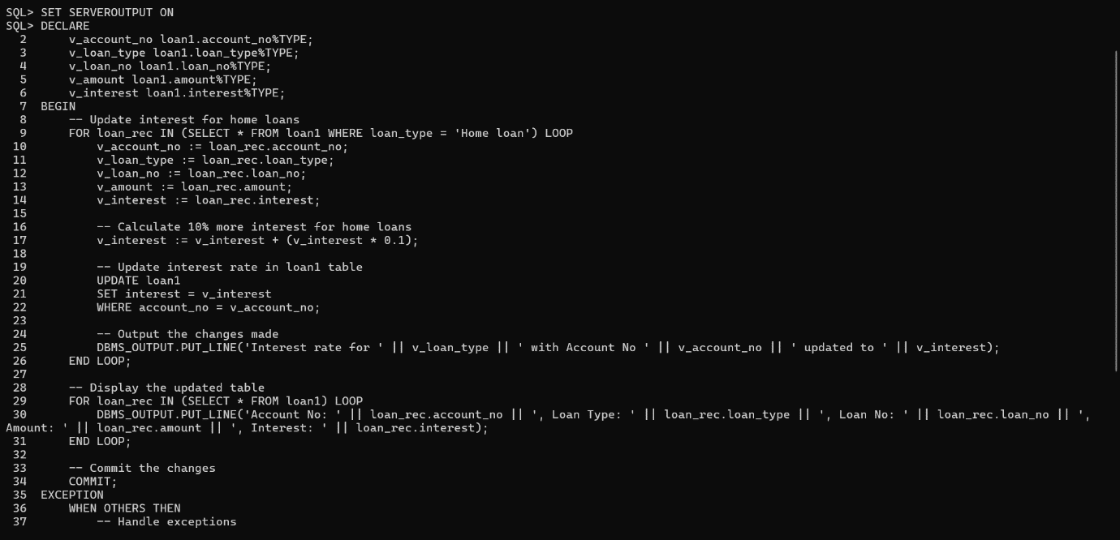

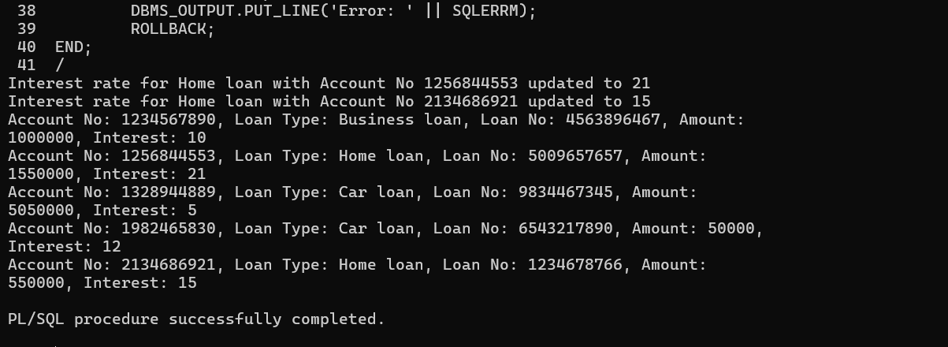

Q2:Write a before trigger to add 10000 ruppee to customer table debit card whose amount is more than 75000

ANSWER: BEFORE INSERT trigger

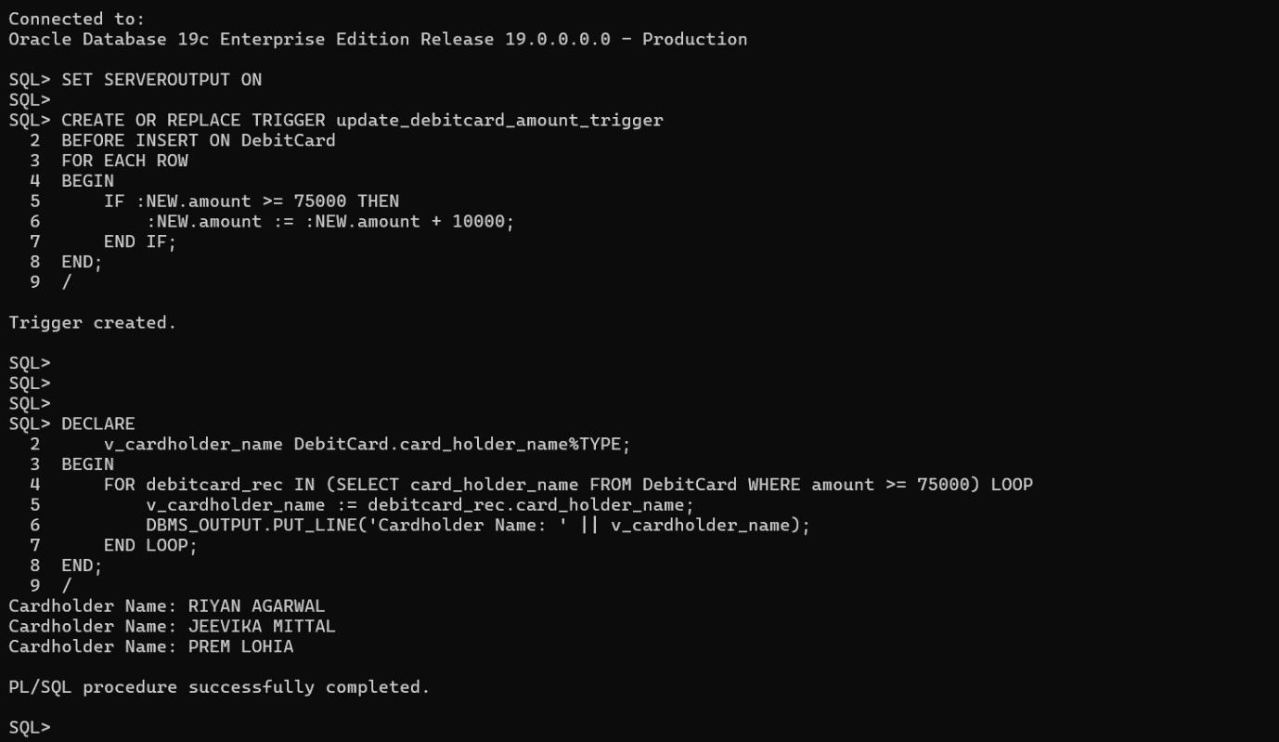

Q3:Write a plsql code of explicit cursor to display all the email_id af all customer name from table customer

ANSWER: EXPLACIT CURSOR

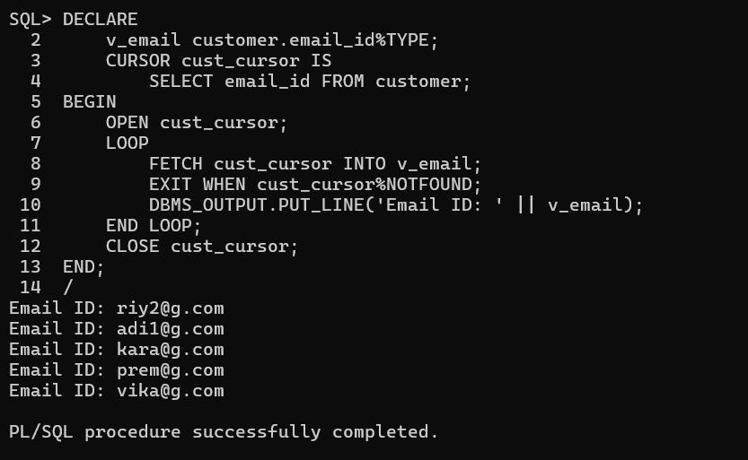

Q4: write a plsql code of implicite cursor to diaplay the card_holder_name of those people who have expiration_date after year 2026 and also display result as an output

ANSWER: IMPLICIT CURSOR

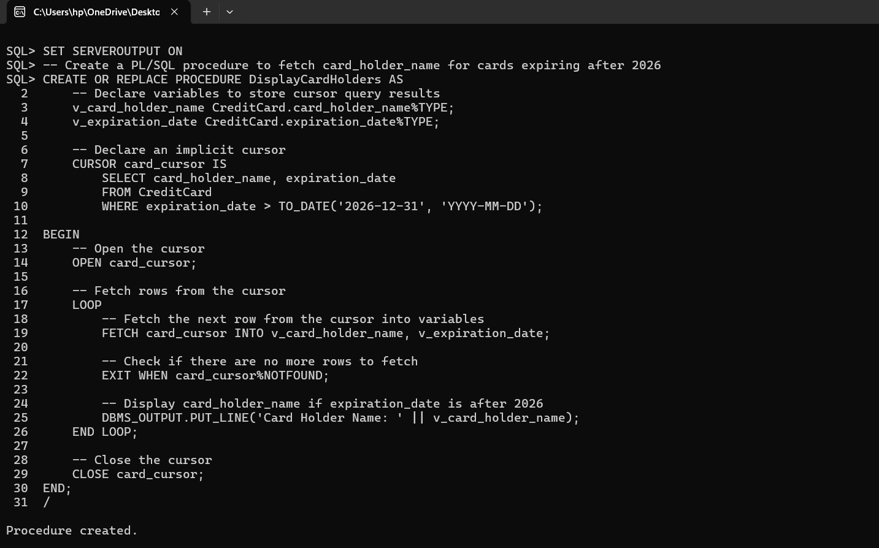

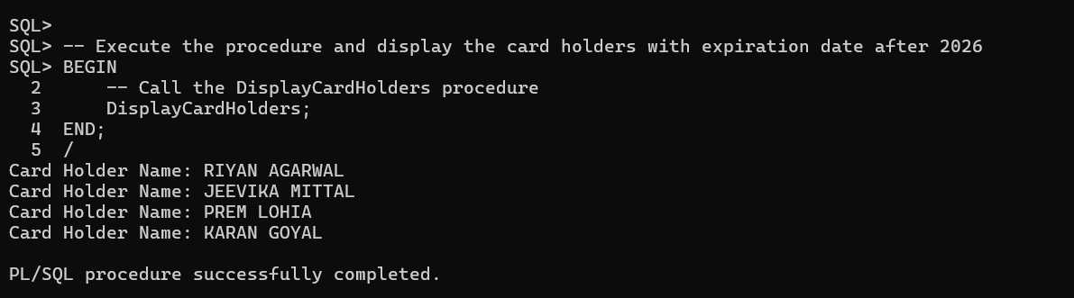

Q5 : create a view and add all column from customer and add card no and amount from debit card and also show the view as output with table name view1

ANSWER: CREATING VIEW1

